SMART STUDENT MANAGER
A Python-Based Academic Management Desktop Application
Project Detail | Student Information
Student Name | Seeya Upadhyay
Roll Number | 26MIB10078
Branch | Integrated M.tech in AI with Bioinformatics
Semester | Semester I
College | VIT Bhopal
Academic Year | 2026-2027

Project Type: Python desktop GUI application
Core Technologies: Python, Tkinter, JSON

Table of Contents
- Introduction
- Problem Statement
- Functional Requirements
- Non-functional Requirements
- System Architecture
- Design Diagrams
- Design Decisions & Rationale
- Implementation Details
- Screenshots / Results
- Testing Approach
- Challenges Faced
- Learning & Key Takeaways
- Future Enhancements
- References

1. Introduction
Smart Student Manager is a Python-based desktop application common academic activities in one place. It uses Tkinter for the graphical interface and JSON files for local persistence. The project demonstrates Python programming, GUI development, file handling, validations, calculations, and modular software design.
The application contains six major modules: Student Profile, Attendance Manager, Assignment Manager, Study Planner, CGPA Calculator, and College Notice Board.
Technology Stack
Technology | Purpose
Programming Language | Python
GUI | Tkinter
Data storage | JSON files
Development Environment | Python IDLE / Python IDE

Project Objectives
- Create a practical academic management system using Python
- Provide a GUI without HTML, CSS, JavaScript, Flask, or SQLite.
- Practice functions, lists, dictionaries, loops, conditions, file handling and exception handling.
- Store records locally using JSON.
- Automate attendance and CGPA calculations.
- Create a project that can be extended in future semesters

2. Problem Statement
Students often manage academic information using notebooks, spreadsheets, messaging applications, or separate files. This makes it difficult to track assignments, attendance, study tasks, academic performance, and college notices in one place.
The project addresses this problem by providing a lightweight desktop application that combines these routine academic tasks without requiring a web server or database.
Proposed Solution
A single Tkinter dashboard provides access to each module. Each module stores its data in a separate JSON file so that records remain available after the application is closed.
Scope
• Individual student use on a local computer.
• Basic academic record management.
• Local JSON-based persistence.
• Simple calculations and task-status management.
• No online account or multi-user synchronization in the current version

3. Functional Requirements
Module | Functional Requirement
Student Profile | Stores student name, roll number, branch, semester and college.
Attendance Manager | Records classes held/attended and calculates attendance percentage.
Assignment | Adds assignment with subject, title, due date and completion status.
Study Planner | Creates study tasks with date, priority and completion status.
CGPA Calculator | Calculator credit-weighted CGPA using credits and grade points.
College Notice Board | Stores college notices with title, date and notice text.
Detailed Functional Requirements
• The system shall allow the user to create and update a student profile.
• The system shall record subject-wise classes held and attended.
• The system shall calculate attendance percentage.
• The system shall add, complete and delete assignments.
• The system shall create study tasks with dates and priorities.
• The system shall calculate credit-weighted CGPA.
• The system shall add and delete college notices.
• The system shall save module data in JSON files.
• The system shall validate required fields and basic numeric input.

4. Non-functional Requirements

Requirement | Description
Usability | Clear labels, buttons and simple navigation for student users.
Performance | Normal student-sized data should be processed quickly.
Reliability | Missing JSON files and common invalid inputs should not crash the application.
Maintainability | Separate functions make individual modules easier to modify.
Portability | Runs on a compatible Python installation with Tkinter.
Data Persistence | Records remain available after closing and reopening the application.
Simplicity | Avoids unnecessary external frameworks and infrastructure
Constraints
• The application is local and does not synchronize between devices.
• JSON does not provide advanced querying/concurrency features of a relational database.
• The current version is designed for a single student.

5. System Architecture
The application uses a simple layered structure. The Tkinter interface collects input and displays results. Application logic performs validation, calculations and record updates. JSON files provide local persistence.

Tkinter GUI

Student / User
Application Logic

JSON Storage

General Data Flow
- Open dashboard and select a module.
- The module reads its JSON file.
- User enters or views data.
- The program validates input and updates the JSON file.
- The interface refreshes the displayed list

6. Design Diagrams
- Sequence Diagram
Interaction between Student, Tkinter GUI, application logic and JSON storage

Student Tkinter GUI Logic JSON

Select module
Enter data
Validate
Save/update
Display
Read/update

- Class / Component Diagram
The Implementation-oriented, so a component/module diagram is more accurate than a traditional class diagram

Profile
Main Dashboard

Assignments
Attendance

CGPA + Notices
Study Planner

- ER Diagram / Data Model
Because the project uses JSON rather than SQL, this diagram represents the logical data entities.
Student Profile
Name
Roll
Branch
Semester
Attendance
Subject
Held
Attended
Percentage

Study Task
Subject
Task
Date
Priority
Status

Assignment
Subject
Title
Due _date
Status

Notice
Title
Date
Notice

CGPA Record
Subject
Credits
Grade _point

7. Design Decisions & Rationale

Decision | Rationale
Python | Suitable for a first-semester engineering project and rapid GUI development.
Tkinter | Simple GUI toolkit available with Python installations.
JSON | Easy to read, write, debug and understand  For beginner-level persistence.
Separate JSON files | Keeps module data independent.
Functions | Demonstrates modular programming and keeps the source understand.
Top level windows | Allows modules to open separately from the main dashboard.
Input validation | Prevents common invalid values and improves reliability.

Why no HTML/CSS/JavaScript/Flask/SQLite?
The current project is intentionally a local Python desktop application. Tkinter provides the graphical interface directly in Python, while JSON provides lightweight local storage. This keeps the technology stack appropriate for a beginner-level Python engineering project.

8. Implementation Details
8.1 Program Structure
The program defines JSON filenames and reusable load/save helper functions. Each feature is implemented as a separate function that opens a Tkinter Top level window.
8.2 JSON Persistence
Load _ json () checks whether a file exists and returns a default empty structure when it does not. save _ json () writes the current Python data to the corresponding JSON file.
8.3 Attendance Calculation
Attendance % = (Classes Attended / Classes Held) × 100
The program checks that classes held is positive and attended classes are not negative or greater than classes held.
8.4 CGPA Calculation
CGPA = S (Credit × Grade Point) / S (Credits)
Grade points are restricted to 0–10 in the current implementation.
8.5 Status Management
Assignments and study tasks begin with Pending status and can be marked Completed.
8.6 Error Handling
• Missing required fields trigger warning message boxes.
• Invalid numeric input is handled with try/except.
• Missing JSON files are treated as empty datasets.
• Actions requiring a selected record warn the user if none is selected.

9 Screenshots / Results
Insert screenshots of the actual running application in this section. The following placeholders show the recommended screenshots.
Fig 1 Main Smart Student Manager dashboard
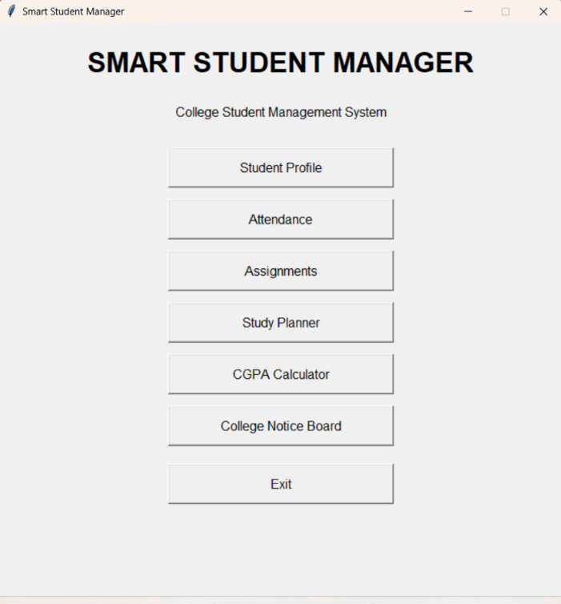
Fig 2 Student Profile window
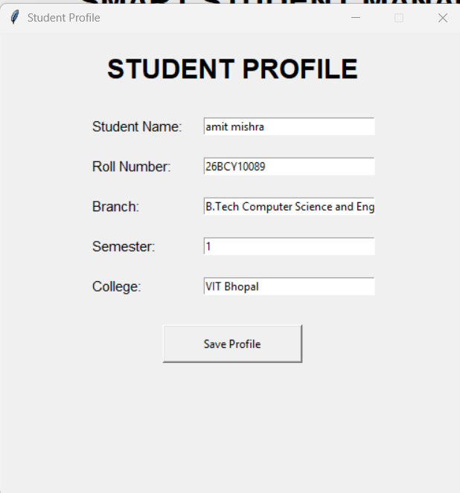

Fig 3 Attendance Manager
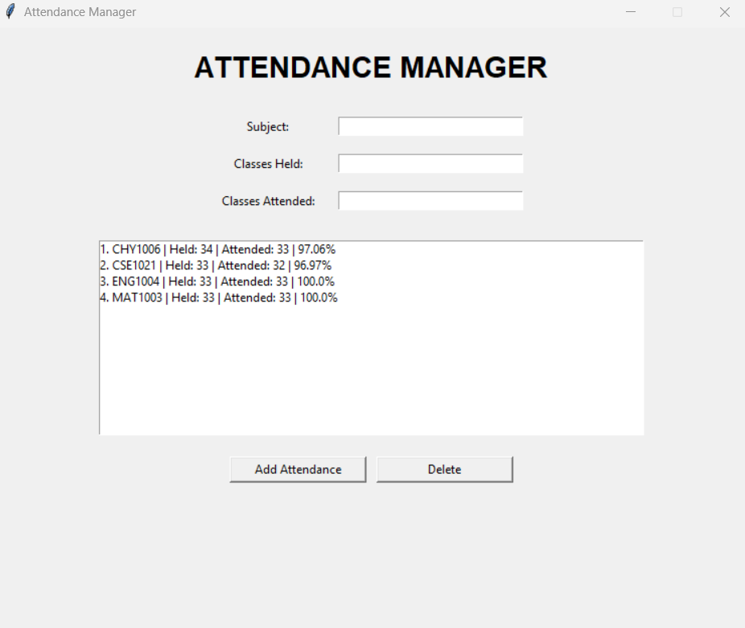
Fig 4 Assignment Manager
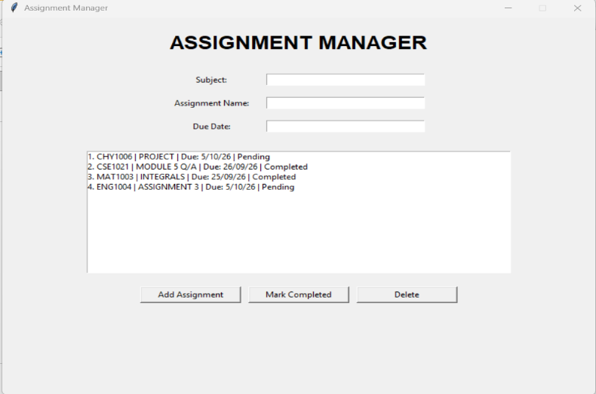
Fig 5 Study Planner
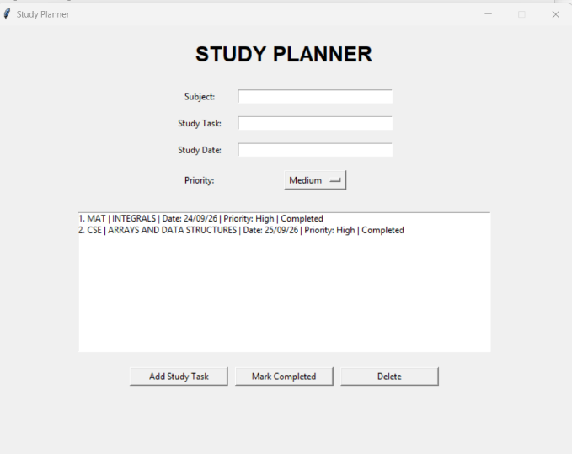
Fig 6 CGPA Calculator
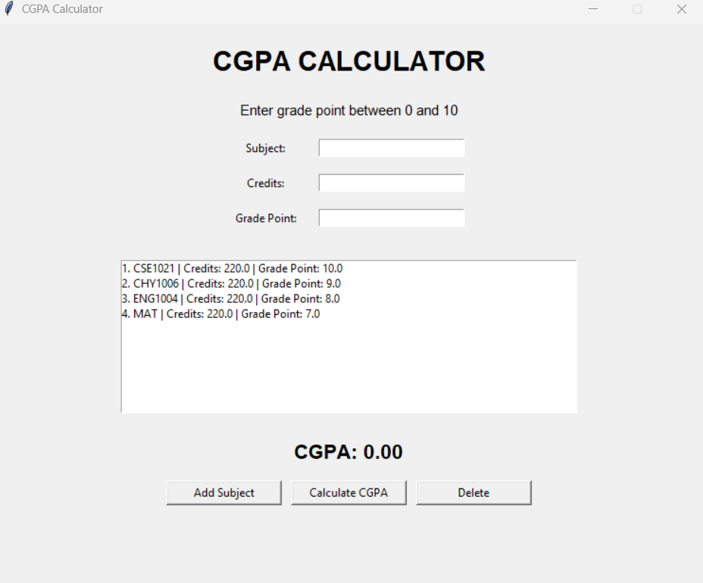
Fig 7 College Notice Board
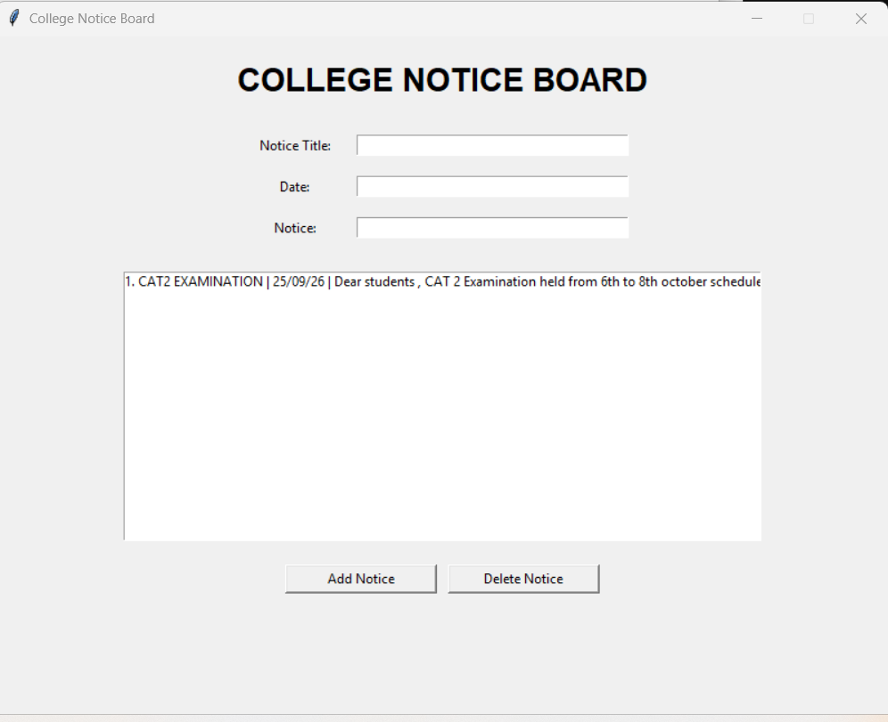

10. Testing Approach
Testing is based on functional test cases covering normal input, invalid input, record selection, saving and reopening.
Test Case | Input / Action | Expected Result
TC01 | Saved valid profile | Profile is saved
TC02 | Leave a profile field empty | Warning displayed
TC03 | Enter valid attendance | Percentage calculated and saved
TC04 | Enter attended > held | Invalid data warning
TC05 | Add assignment | Assignment appears as pending
TC06 | Mark assignment completed | Status becomes completed
TC07 | Add study task | Task appears in the list
TC08 | Grade point outside 0-10 | Invalid data warning
TC09 | Calculate CGPA | Weighted CGPA displayed
TC10 | Add notice | Notice appears
TC11 | Reopen application | Saved records remain
TC12 | Delete selected record | Record is removed

Expected Testing Result
All normal operations should work through the GUI, common invalid inputs should produce user-friendly warnings, and records should persist in the corresponding JSON files.

11. Challenges Faced
• Managing several modules under one dashboard.
• Handling JSON files safely.
• Validating numerical input.
• Keeping list indexes synchronized with saved records.
• Learning Tkinter layout and event handling.
• Debugging indentation, function placement and button callbacks.
How the Challenges Were Addressed
The project uses small functions for each operation, reusable JSON helper functions, input validation and message boxes. This reduces repeated code and makes debugging easier.

12 Learning & Key Takeaways
• Python functions and modular programming.
• Tkinter GUI widgets and event-driven programming.
• JSON data storage and file handling.
• Exception handling and input validation.
• Real-world problem decomposition into software modules.
• Testing, documentation, diagrams and repository organization.
• Importance of keeping code, diagrams and documentation consistent

13 Future Enhancements
• Login and multi-user support.
• Search, sorting, filtering and editing.
• Automatic reminders and notifications.
• Attendance shortage alerts.
• Semester-wise and cumulative CGPA tracking.
• Charts for attendance and academic performance.
• PDF/Excel export.
• SQLite storage for larger structured data.
• Conversion to a web application using Flask or another framework.
• Cloud synchronization

14. References
• Python Documentation — Python language and standard library reference.
• Tkinter Documentation — GUI programming with Python's Tk interface.
• Python json module documentation — JSON encoding and decoding.
• Python os module documentation — file and operating-system interface.
• GitHub Documentation — repository management and version control.

